**16.3. How to make Integer Field Required (freePasses)**

**Make Integer field requires**:

In this example we have a form and four field in this form. The field are “First Name”, “Last Name”, “Free Passes”, and “Postal Code”. Here “Free Passes” take an integer value. We make this field required.

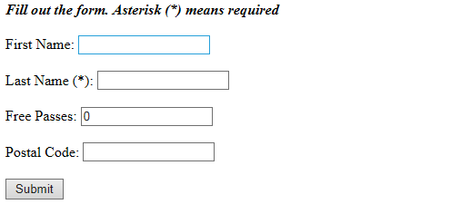

**Customer.java**:

**package** com.ruhul.odduu.springmvc;

**import** javax.validation.constraints.Max;

**import** javax.validation.constraints.Min;

**import** javax.validation.constraints.NotNull;

**import** javax.validation.constraints.Pattern;

**import** javax.validation.constraints.Size;

**public** **class** Customer {

**private** String firstName;

@NotNull(message = "is required")

@Size(min = 1, message = "is required")

**private** String lastName;

@NotNull(message="is required")

@Min(value = 0, message = "must be greater than or equal to zero")

@Max(value = 10, message = "must be less than or equal to zero")

**private** **int** freePasses;

@Pattern(regexp = "^[a-zA-Z0-9]{5}", message = "Only 5 chars/digits")

**private** String postalCode;

**public** String getPostalCode() {

**return** postalCode;

}

**public** **void** setPostalCode(String postalCode) {

**this**.postalCode = postalCode;

}

**public** **int** getFreePasses() {

**return** freePasses;

}

**public** **void** setFreePasses(**int** freePasses) {

**this**.freePasses = freePasses;

}

**public** String getFirstName() {

**return** firstName;

}

**public** **void** setFirstName(String firstName) {

**this**.firstName = firstName;

}

**public** String getLastName() {

**return** lastName;

}

**public** **void** setLastName(String lastName) {

**this**.lastName = lastName;

}

}

**customer-form.jsp**:

<%@ taglib prefix=*"form"* uri=*"http://www.springframework.org/tags/form"*%>

<html>

<head>

<meta charset=*"ISO-8859-1"*>

<title>Customer Registration Form</title>

<style type=*"text/css"*>

*.error* {

color: *red*;

}

</style>

</head>

<body>

<i><b>Fill out the form. Asterisk (*) means required</b></i>

<br></br>

<form:form action=*"processForm"* modelAttribute=*"customer"*>

First Name: <form:input path=*"firstName"* />

<br></br>

Last Name (*): <form:input path=*"lastName"* />

<form:errors path=*"lastName"* cssClass=*"error"* />

<br></br>

Free Passes: <form:input path=*"freePasses"* />

<form:errors path=*"freePasses"* cssClass=*"error"* />

<br></br>

Postal Code: <form:input path=*"postalCode"* />

<form:errors path=*"postalCode"* cssClass=*"error"* />

<br></br>

<input type=*"submit"* value=*"Submit"* />

</form:form>

</body>

</html>

Here we make the “Free Passes” field required and this field take an integer value. But when we submit the form if the “Free Passes” field is empty we will get the following error.

Failed to convert property value of type java.lang.String to required type int for property freePasses; nested exception is java.lang.NumberFormatException: For input string: ""

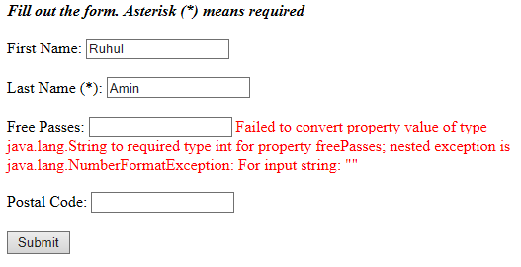

**The reason behind the error**:

@NotNull working for String fields, displaying custom message as required,but for int fields still showing same :Failed to convert property value of type java.lang.String to required type int for property freePasses; nested exception is java.lang.NumberFormatException: For input string: ""

**Solution**:

To solve this error use wrapper class to declare int variables so that wrapper class will convert whitespace to null.

**Customer.class**:

**package** com.ruhul.odduu.springmvc;

**import** javax.validation.constraints.Max;

**import** javax.validation.constraints.Min;

**import** javax.validation.constraints.NotNull;

**import** javax.validation.constraints.Pattern;

**import** javax.validation.constraints.Size;

**public** **class** Customer {

**private** String firstName;

@NotNull(message = "is required")

@Size(min = 1, message = "is required")

**private** String lastName;

@NotNull(message="is required")

@Min(value = 0, message = "must be greater than or equal to zero")

@Max(value = 10, message = "must be less than or equal to ten")

**private** Integer freePasses;

@Pattern(regexp = "^[a-zA-Z0-9]{5}", message = "Only 5 chars/digits")

**private** String postalCode;

**public** String getPostalCode() {

**return** postalCode;

}

**public** **void** setPostalCode(String postalCode) {

**this**.postalCode = postalCode;

}

**public** Integer getFreePasses() {

**return** freePasses;

}

**public** **void** setFreePasses(Integer freePasses) {

**this**.freePasses = freePasses;

}

**public** String getFirstName() {

**return** firstName;

}

**public** **void** setFirstName(String firstName) {

**this**.firstName = firstName;

}

**public** String getLastName() {

**return** lastName;

}

**public** **void** setLastName(String lastName) {

**this**.lastName = lastName;

}

}

16.3. How to make Integer Field Required (freePasses)